1. **Preface.** In recent years crime related to vehicle has been on a rise and security breaches in conservative areas such as Cantonment is becoming a common phenomenon. In order to minimize these security breaches by identifying each and every vehicle which enters the Cantonment area, Military Police (MP) have been working 24/7 at every Check Post (CP) by asking the identity of the individuals manually. To eradicate this problem and ease up their work, **Automated Vehicle RFID In-Out Autonomous System at MP CP** will be used. This system will automatically gather information about the vehicle which enters through the CP using RFID Scanner and store it in a database. This is the future of the MP CPs.
2. **Introduction**

**2.1** **Purpose.**

The present MP check post is not automated. We still follow the traditional system of checking car by car about the identity and motive of the vehicle to enter cantonment. Furthermore, we don’t have a proper identification management system to fully give the desired security at the MPCP. The traditional system requires more time and manpower. The purpose of our project is:

* To ensure proper identification of a vehicle
* To prevent unauthorized personnel from entering Cantonment.
* To save time during the checking of MP at MPCP.
* To keep track on who are entering the Cantonment.
* To reduce mistakes caused by human fatigue.

**2.2 Intended Audience.**

The product will be made for all MP units in all the Cantonments of Bangladesh Army. MPCP of the Cantonments will have access to it. Authorized officer from the MP Unit and the intelligence organizations will have authorization to access the database manually.

**2.3 Product Scope.**

The product is for all MPCPs of all the Cantonments of Bangladesh Army.Our main focus will be accuracy of result, proper identification of vehicle information, and prevention of unauthorized entry into Cantonment.

**2.4 Objective.**

To digitalize the MPCP with a view to making a more secure and efficient check post for the Military Police and ensure proper identification of any vehicle entering the Cantonment.

**4.1. Requirement Discovery:**

**4.1 Literature Review:**

**We have found out several journals and IEEE papers about RFID scanner system and how it is implemented. Reference of the journals are attached below:**

* RFID research: An academic literature review (1995–2005) and future research directions

1. Department of Management and Marketing, The Hong Kong Polytechnic University, Kowloon, Hong Kong, PR China
2. Institute of Textile and Clothing, The Hong Kong Polytechnic University, Kowloon, Hong Kong, PR China
3. Department of Information and Decision Sciences, Carlson School of Management, University of Minnesota, USA

Received 1 March 2006, Accepted 12 December 2006

* A literature review on the impact of RFID technologies on supply chain management

1. Ecole des Mines de Saint-Étienne, CMP, Site Georges Charpak, 880 Avenue de Mimet, F-13541 Gardanne, France

Received 27 January 2009, Accepted 22 July 2010

**5.1. User Requirement:**

**5.1.1.**Make a profile for each vehicle and the owner that will be accessible only by the MP unit.

**5.1.2.** Before entering through the MPCP, monitoring the vehicle movement and scanning the RFID and send it to the system application for checking.

**5.1.3.** Make the stored data so accurate and secure.

**5.1.4.** User should be informed by an alarm if any unregistered vehicle is trying to enter through the MPCP.

**5.1.5.** Give the proper disposal for the unregistered vehicle entering the Cantonment.

**6.1. System Architecture.**

|  |  |
| --- | --- |
| **Name** | **Repository** |
| **Description** | All data in a system is managed in a central repository that is accessible to all system components. Components do not interact directly, only through the repository. |
| **Example** | Figure 6.1 is an example of an RFID scanning system where the components use a repository of system design information. Each software tool generates information which is then available for use by other tools. |
| **When used** | This pattern is used when a system in which large volumes of information are generated that has to be stored for a long time. It may also be used in data-driven systems where the inclusion of data in the repository triggers an action or tool. |
| **Advantages** | Components can be independent—they do not need to know of the existence of other components. Changes made by one component can be propagated to all components. All data can be managed consistently (e.g., backups done at the same time) as it is all in one place. |
| **Disadvantages** | The repository is a single point of failure so problems in the repository affect the whole system. May be inefficiencies in organizing all communication through the repository. Distributing the repository across several computers may be difficult. |

**RFID Reader**

**User Info**

**Owner Info**

**Database**

**Veh Info**

**Timing**

**Fig (6.1): Repository architecture for Automated vehicle IN-OUT autonomous system at MPCP**

**7.1. System requirement specifications.**

**7.1.1. User friendly interface.**

7.1.1.1. No complex functionality.

7.1.1.2 Easy to fit in the vehicle.

7.1.1.3. Does not hamper with driving.

**7.1.2.** **Accuracy and time.**

7.1.2.1. It should be 100% accurate otherwise the RFID scanner won’t be able to detect the RFID tag.

7.1.2.2. It should be able to detect the RFID tag before the next vehicle passes so it should be punctual about timing.

**7.1.3. Alarm system.**

7.1.3.1. If a new car enters which is not registered in database then the MP at the gate is notified so that proper identification can be taken.

**7.1.4. Identification and storing of data.**

7.1.4.1. The system should identify the information of the car and store it in the database accordingly.

7.1.4.2. The data should be accessible by the concerned authorities without fail.

**7.1.5. Security.**

7.1.5. Database of the car should be secured and no loss of data is acceptable.

**7.1.6. Driver’s profile.**

7.1.6.1. Database will be created where the name, personal number, address, company number, License number, IN-time.

**7.2. Classification of Requirement.**

|  |  |  |  |
| --- | --- | --- | --- |
| **Ser** | **System Requirement** | **Type of Requirement** | |
| **Functional** | **Non-Functional** |
| **1.** | User friendly interface | **❌** | **✔** |
| **2.** | Accuracy and movement time | **❌** | **✔** |
| **3.** | Alarm system | **✔** | **❌** |
| **4.** | Identification and storing of data | **✔** | **❌** |
| **5.** | Security | **❌** | **✔** |
| **6.** | Driver’s profile | ✔ | ❌ |

**8.1. Context Diagram.**

MP

ALARM SYSTEM

DATABASE

AUTO VEHICLE RFID IN/OUT AUTONOMOUS SYSTEM AT MPCP

RFID TAG

VEHICLE

SCAN DISPOSAL

MAINTAIN INFO

VEH INFO

IN

REPORTS

OUT

ALERT USER

**8.2. Use-case Diagram.**

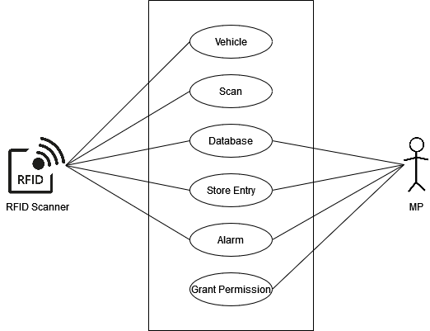

**Tabular Description of “Vehicle Identification” Use-case.**

|  |  |  |
| --- | --- | --- |
| **Vehicle Identification** | |  |
| **Actors** | RFID Scanner, MP | |
| **Description** | RFID Scanner will scan the RFID tag on the vehicle and send it to the database that is maintained by the MP authority. The information transferred will be personal info eg owner name, vehicle id, license no, personal no, address, company no and the in time of the vehicle. If the vehicle is not identified, the alarm will set off. | |
| **Data** | Vehicle information, In/Out summary. | |
| **Stimulus** | RFID tag scanned. | |
| **Response** | Confirmation that the vehicle info is updated. | |
| **Comments** | The MP must have appropriate security permissions to access the info and database. | |

**8.3. Activity Diagram.**

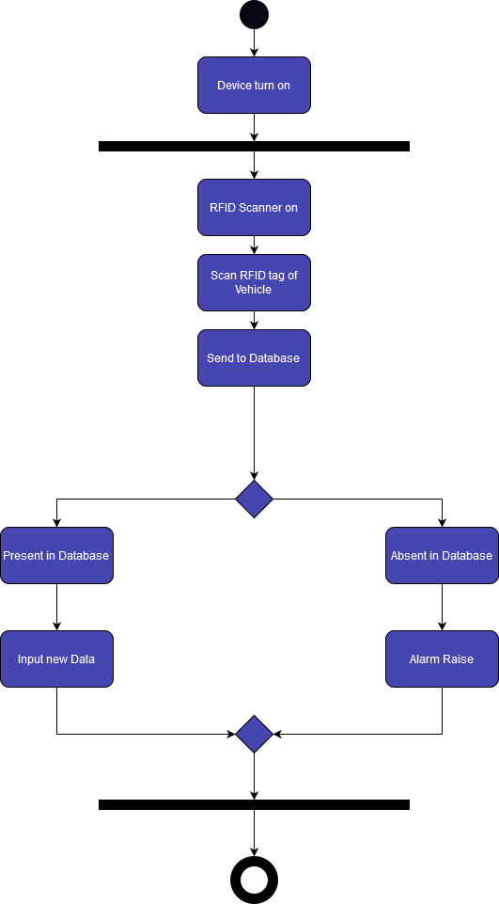

**9. System Evolution.**

There are many possible changes for the evolution of our project. The possibilities for evolution are given below.

1. Face scanner can be added in the future to detect possible people who are on the Cantonment Red Notice Board to stop them from entering the Cantonment.
2. Presently we can only focused on the Cantonment MPCP. This project can be later applied to all over the city in various cross roads and stoppages.

10. Appendix.

10.1. Questions of the Survey.

1. Do you think the present vehicle recognition system validate the unique identification of vehicles?

2. Do you think that the RFID based system would facilitate the current system?

3. Do you think the RFID based system will be able to provide adequate security to monitor the movement ?

4. The RFID based system can mitigate manual way of checking the vehicle and its owner which is more accurate and time efficient- do you agree with the statement?

5. Do you think the RFID based system can be implemented in all the army regulated area ?

6. What should be the platform of RFID based system?

7. What kind of functionalities do you expect out of RFID based system if it is implemented in every entry point of the cantt or any army regulated area?

8. Few days back there was an fraudulent incident of uber driver in the road adjacent to NDC at Mirpur Cantt. But due to overspeed the rider escaped from the place and MP's couldn't track him down. Do you think if we implement the RFID based system in every entry point of the cantt will we able to mitigate this type of scenario?

9. Do you think the RFID based system will modernize all the cantt and ensure the proper security?